LAB Logbook

Lab 1

Lab 2

1. A blue line graph on a white background

   Description automatically generated0.922
2. A blue line graph on a white background

   Description automatically generated
3. 0.940
4. 0.914
5. 0.905A graph showing a growth

   Description automatically generated with medium confidenceA blue line on a white background

   Description automatically generated

Lab 3

Lab 4

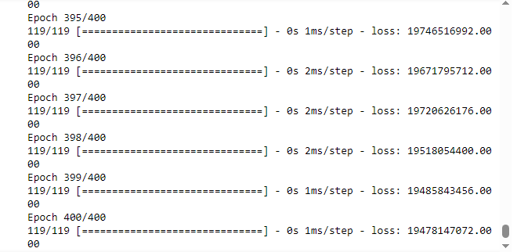

Lab 5

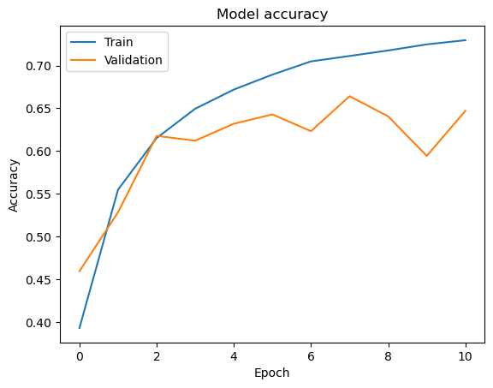

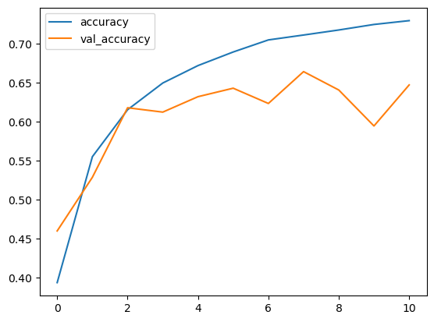

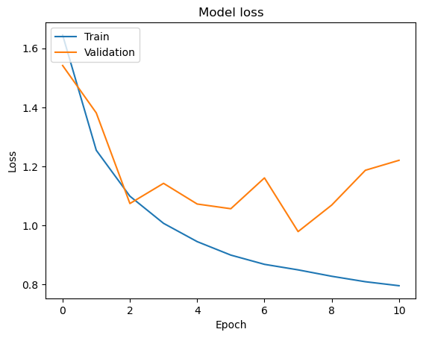

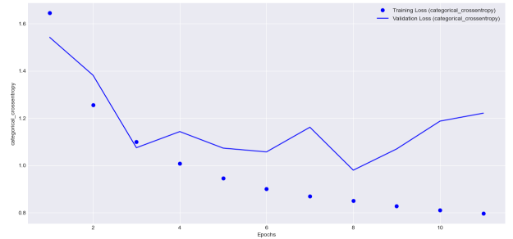

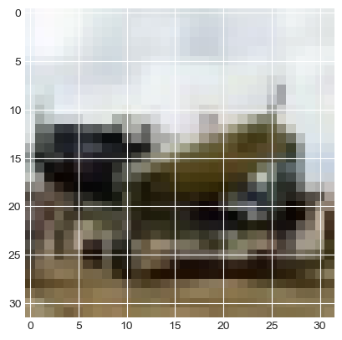

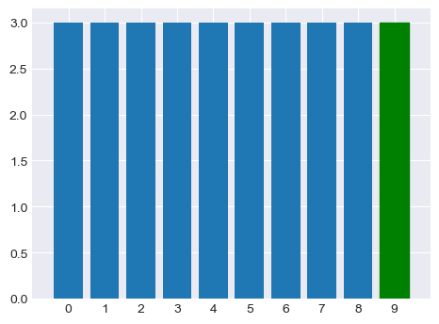

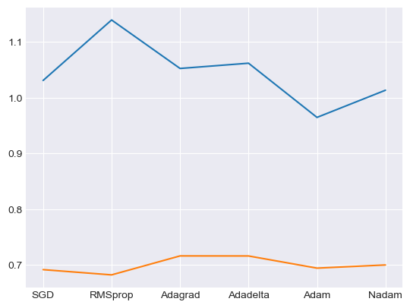

Lab 6

Lab 7

Lab 8

Lab 9

Lab 10

Lab 11

Lab 12

